Is your project steak burning?
By Ida Rohne
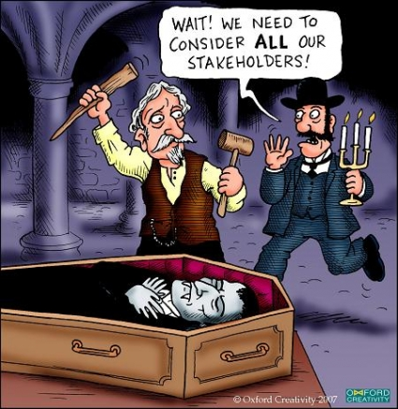

It should be high priority to manage those who are impacted by, and capable of impacting, your project. And, not only manage, but analyse, assess, involve, and seek feedback and listen.

How much influence do stakeholders have? How interested are they in the project? Are they resistant, supportive or neutral? What are their needs and preferred mode of communication?

If you have implemented a framework to document and monitor stakeholders and applied metrics to calculate their level of power, you are engaging in best practice Project Management. If not? Well, you might be operating on presumptions and taking huge risks.

Despite research, surveys and the voices of experts, many projects suffer due to scarcity of sound stakeholder and communications management. A program director I once came across confirmed this. “Stakeholder? That’s someone who holds a steak at a BBQ, isn’t it” he laughed as he walked off with far more important things to do than discuss communications. The operational manager further reinforced my already frustrated outlook. “This doesn’t matter, they’ll be dragged kicking and screaming whether they like it or not,” was his response to my detailed stakeholder analysis and communication plan. Another common reaction is; “we don’t have time for that here.” Sadly, this sums up Communications Management in many organisations, and emphasises the need to address barriers to effective communication on projects.

Lack of diversity may play a part. Project management is dominated by certain sectors such as, for example, Technology, Engineering or Finance, resulting in projects being managed with disproportionate focus in these areas while people aspects are forgotten or ignored. Since these fields are traditionally male dominated, we also have gender imbalance in project management, which does little to remedy communication disparity.

In addition, attitudes to managing communications are closely linked to leadership and organisational culture, and management ‘sets the tone’ here as in other areas of business process.

It is worth considering links between gender imbalance, sector dominance and lack of importance given to communications management.

Also, contemplate for a moment the skillsets favoured in project managers. Many will agree that project management can be successfully applied to any field. Then it logically follows that project managers from a range of backgrounds can successfully manage projects. Provided experience and qualifications are equal, there is no reason why a project manager with a Humanities background should be less suited to the role than someone with an Engineering background. Lack of value placed on experience from a broader knowledge base is counterproductive to the development of project management and restricts professionals from ‘non-dominant’ sectors, who could potentially contribute with good leadership and communication skills, from establishing themselves in project management.

This highlights the issue of the project manager’s role. A project manager needs to have the language to confidently discuss issues that are important to everyone in a cross functional team. He, or she, does not, however, need to be a subject matter expert. The project manager’s expertise should be Project Management, a large part of which is managing people. A project manager must know how to influence people and win them over, and this means possessing superior negotiation and communication skills. By moving away from a narrow approach, we are in a better position to appreciate Project Management as a discipline in its own right and ascribe equal importance to all knowledge areas, including Communications Management.

Although reasons for project failure are varied, complex and numerous, lack of communication and stakeholder engagement are common factors. A glaring example is the $40M Qantas ‘Jetsmart’ project which was renamed ‘Dumbjet’ after aircraft engineers deemed a new parts management system unusable and unions threatened industrial action. Qantas had to start from scratch after the project was rejected caused by a failure to involve the most crucial stakeholders, the end-users.

Know your stakeholders, understand their needs and how they are likely to influence your project, involve them if appropriate, and monitor their influence and interest. Dissatisfied stakeholders don’t care if your project is on time, on budget and within scope, but they do care how your project is affecting them.

http://calleam.com/WTPF/?page_id=799

